Code Location

https://github.com/JAGASABARIVEL/Java/tree/master/Front%20End%20Project/ProjectKitchen

Project Snapshot

User home page
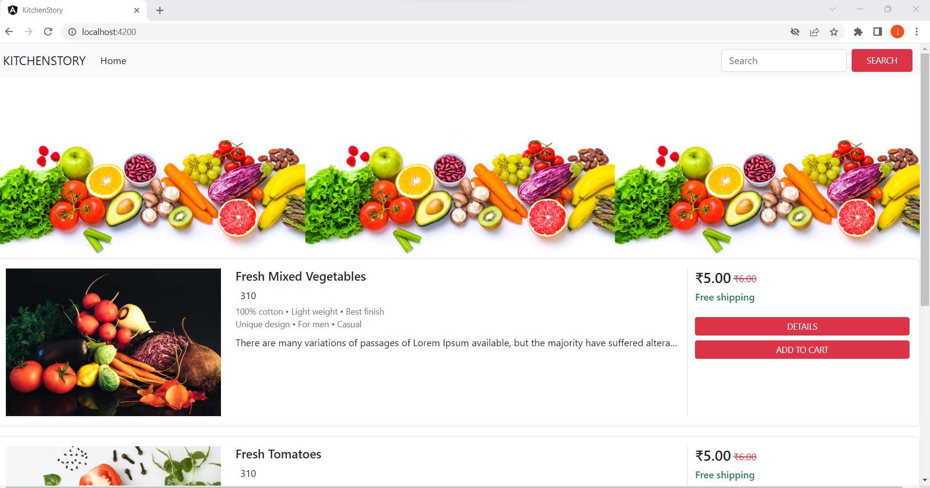

Add to cart page
